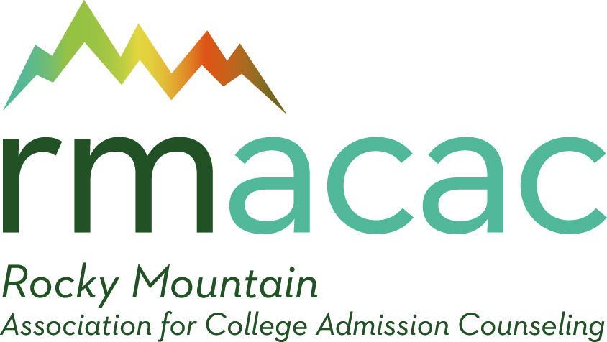

RMACAC Student Scholarship Counselor Nomination Form

Applicant’s Name ______________________________________

Applicant Instructions
1. In order to be eligible to apply for the RMACAC student scholarship, you must be nominated by a current, paid member of RMACAC by completing this form. All RMACAC members are eligible to nominate students, but student applicants must either be a resident or attend school in one of five member states: Arizona, Colorado, New Mexico, Utah, or Wyoming to be eligible for the scholarship.

Waiver of Applicant’s Rights:
According to law, a student may waive his or her right to examine any document in his or her
file. Failure to waive will not be prejudicial to the student.

By signing this statement, I, the applicant, waive all rights of access to this document.

______________________________________ _______________________________
Student’s Signature Date

Reference Writer Instructions
The above named applicant is applying for the RMACAC student scholarship. Along with the applicant’s application form and essay, the scholarship committee will read your nomination to assess each candidate. Your recommendation will be very important to the scholarship committee as they make the final recipient decisions.
1. Complete this nomination form for the applicant.
2. Please email this form directly to Darah Tabrum, RMACAC IDEA Chair at RMACAC.IDEA@gmail.com

RMACAC Student Scholarship Counselor Nomination Form

Applicant’s Name: ______________________________________________________________________________

For how long and in what capacity have you known the applicant?

______________________________________________________________________________

_____________________________________________________________________________

_____________________________________________________________________________

Please rate the applicant as candidly as possible by circling the applicable number.

1 – No Evidence 4 –Good
2 – Poor 5 – Excellent
3 – Average

1. Academic Initiative No Evidence Excellent
a. Works beyond required goals 1 2 3 4 5
b. Shows creativity and originality 1 2 3 4 5
c. Assumes responsibility & determined to earn college degree 1 2 3 4 5

2. Course Selection
a. Takes course loads greater than what is required 1 2 3 4 5
b. Selects courses which display a greater level of difficulty 1 2 3 4 5
c. Selects courses which produce a well-rounded education 1 2 3 4 5

3. Service and Leadership
a. Able & willing to serve others 1 2 3 4 5
b. Shows potential and interest in positively impacting the community 1 2 3 4 5
c. Displays conscientiousness 1 2 3 4 5

4. Academic Potential
a. Able to perform at the college level 1 2 3 4 5
b. Strives to improve 1 2 3 4 5

Write a short recommendation of 250-500 words, endorsing this applicant as a worthy recipient of a RMACAC student scholarship. You may wish to expand on the applicant’s academic strengths as listed above.

Signature: ____________________________________Date: _______________________

